me7120 Project 1

wright state university

Fall 2016

Students: Jeremy Geaslen, Mayank Patel, Mohammed Al Rifaie

Date: 28 Oct 2016

Professor: Dr. Joseph Slater

Contents

Problem Statement 1

Results and discussion 2

Appendix 7

# Problem Statement

## Finite element code

1. Write a general element code to generate the elemental stiffness and mass matrices for a single three-dimensional rod/torsion-rod/beam linearly tapered element for WFEM.
2. Write an additional routine that returns the coordinate transformation matrix.
3. Obtain the FE matrices (M and K) in global coordinates.
4. Write a subroutine to assemble these elements into the global matrix.

## code validation

Check your code by comparing the results of your code to that of ANSYS for a sufficiently complex problem. Be sure to do at least one mesh convergence study in addition to the following bench marks (See 3 below).

1. Static simple and complex (complicated)
2. Dynamic theoretical: compare to closed-form dynamic mode shapes and natural frequencies
3. Prove that choice of coordinate does not change your answers through rotating your problem a partial angle (less than 90 degrees in all three directions)
4. As least one dynamic case unique to your group validated against ANSYS

# Results and discussion

## Deflections of Uniform beam

|  |  |  |  |  |  |
| --- | --- | --- | --- | --- | --- |
| Elements | Closed form | Matlab code | ANSYS | % Error-Matlab | % Error-ANSYS |
| 1 | -1.920477e-04 m | -1.9205e-04 m | -1.568e-04 m | -0.0012 | 18.354 |
| 3 | -1.920477e-04 m | -1.9205e-04 m | -1.919e-04 m | -0.0012 | 0.0769 |
| 5 | -1.920477e-04 m | -1.9205e-04 m | -1.947e-04 m | -0.0012 | -1.3811 |
| 10 | -1.920477e-04 m | -1.9205e-04 m | -1.958e-4 m | -0.0012 | -1.9538 |

## Deflections of Tapered beam

|  |  |  |  |  |  |
| --- | --- | --- | --- | --- | --- |
| Elements | Closed form | Matlab code | ANSYS | % Error-Matlab | % Error-ANSYS |
| 1 | -3.854e-04 m | -2.7282e-04 m | -4.861e-04 m | -29.21 | -26.12 |
| 3 | -3.854e-04 m | -3.6754e-04 m | -3.931e-04 m | 4.634 | -1.99 |
| 5 | -3.854e-04 m | -3.780e-04 m | -3.8807e-04 m | 1.92 | -0.692 |
| 10 | -3.854e-04 m | -3.8257e-04 m | -3.8645e-4 m | 0.734 | -0.272 |
| 20 | -3.854e-04 m | -3.8372e-04 m | -3.9267e-04 m | 0.436 | -1.88 |

## Deflections of complex structure (crane)

|  |  |  |
| --- | --- | --- |
| Matlab code | ANSYS | % Error |
| -3.1388e-06 m | -3.087e-06 m | 1.65 |

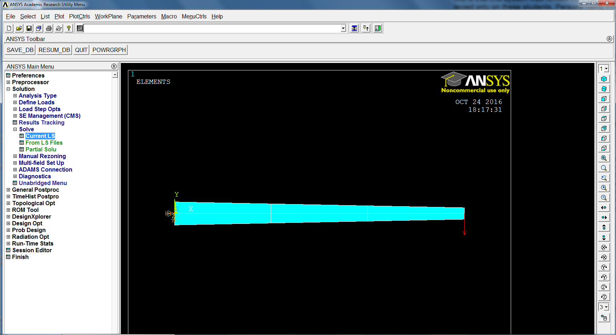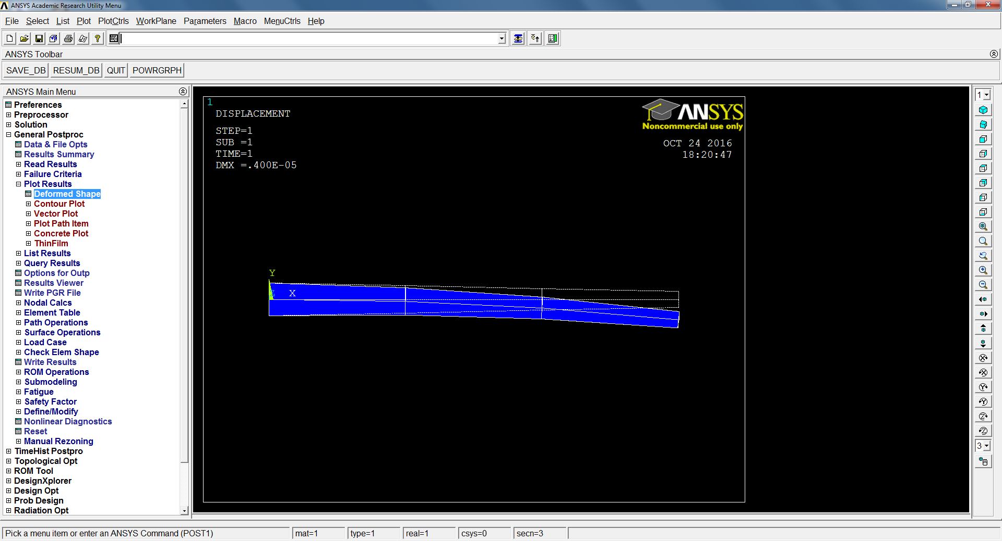

Figure 1: Loads and BCs of 3-element tapered beam.

Figure 2: Deformed shape of 3-element tapered beam.

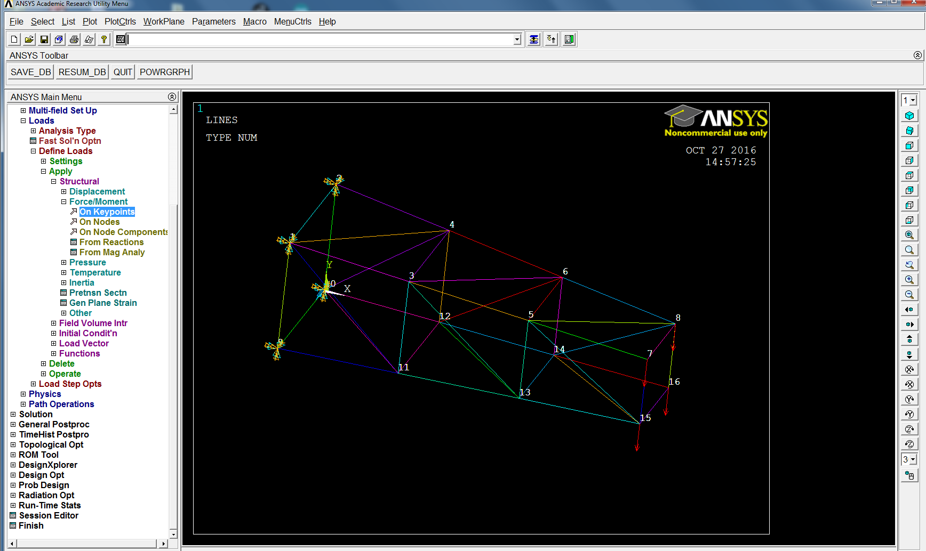

Figure 3: The deformed shape and the maximum deflection for complex crane structure in ANSYS.

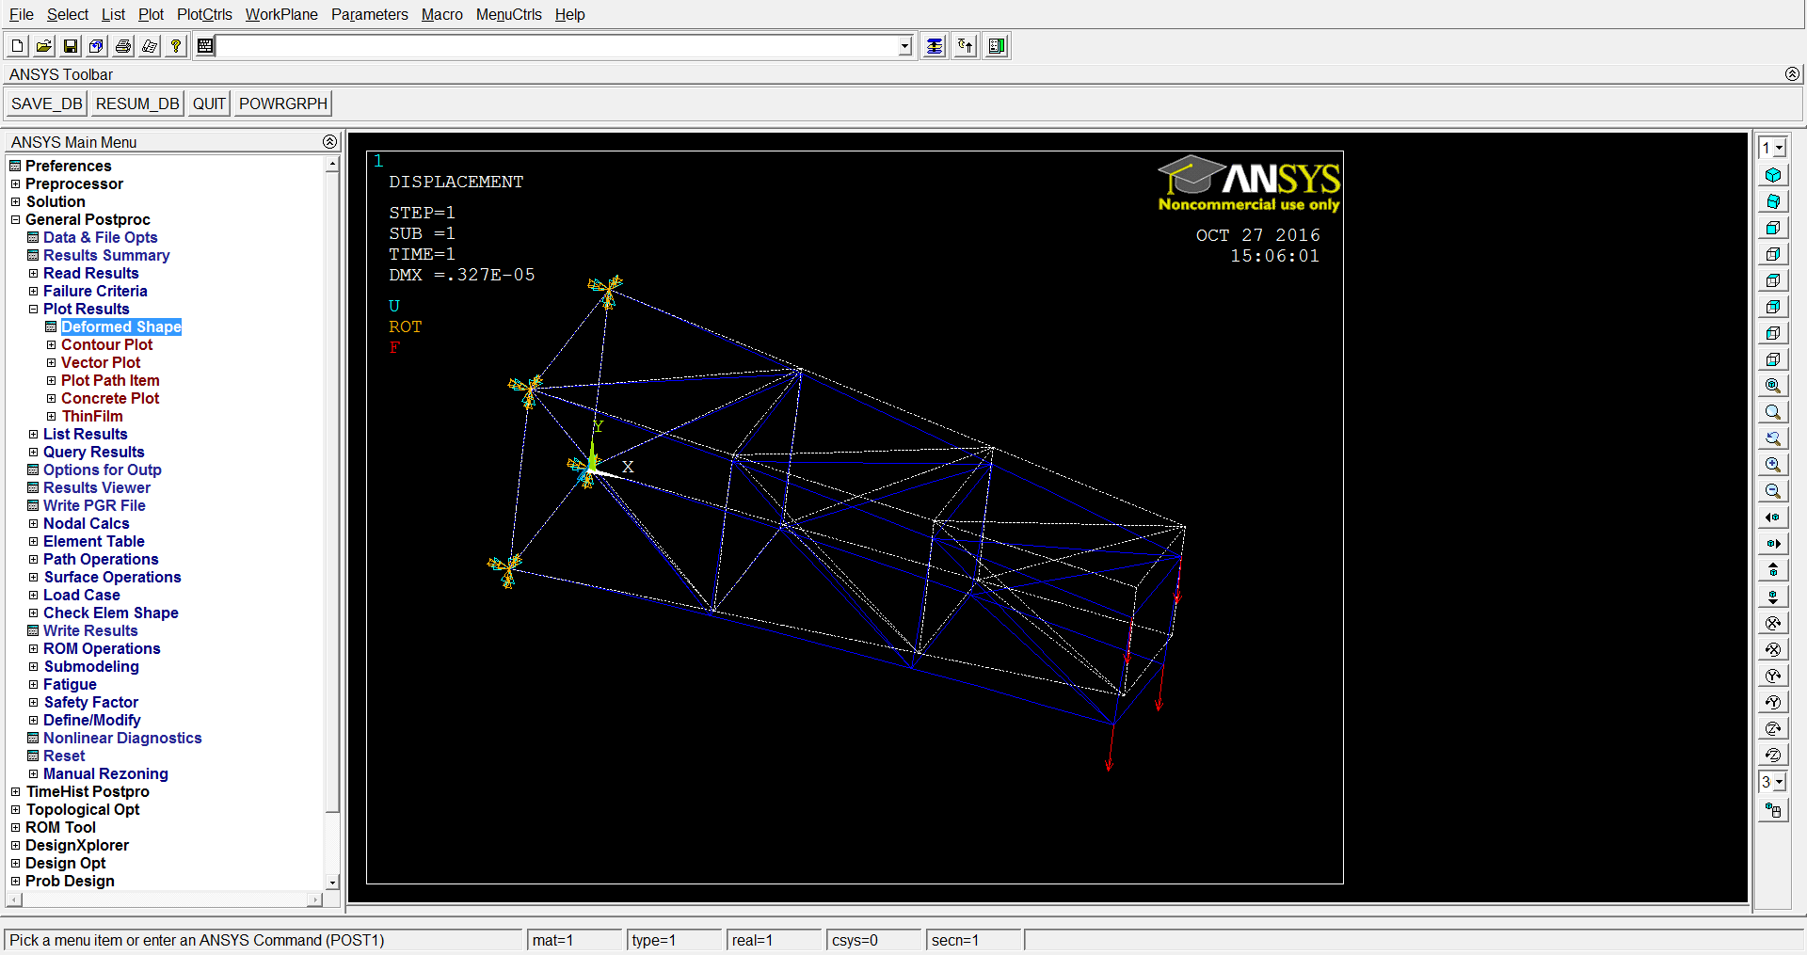

Figure 4: The deformed shape and the maximum deflection for complex crane structure in ANSYS

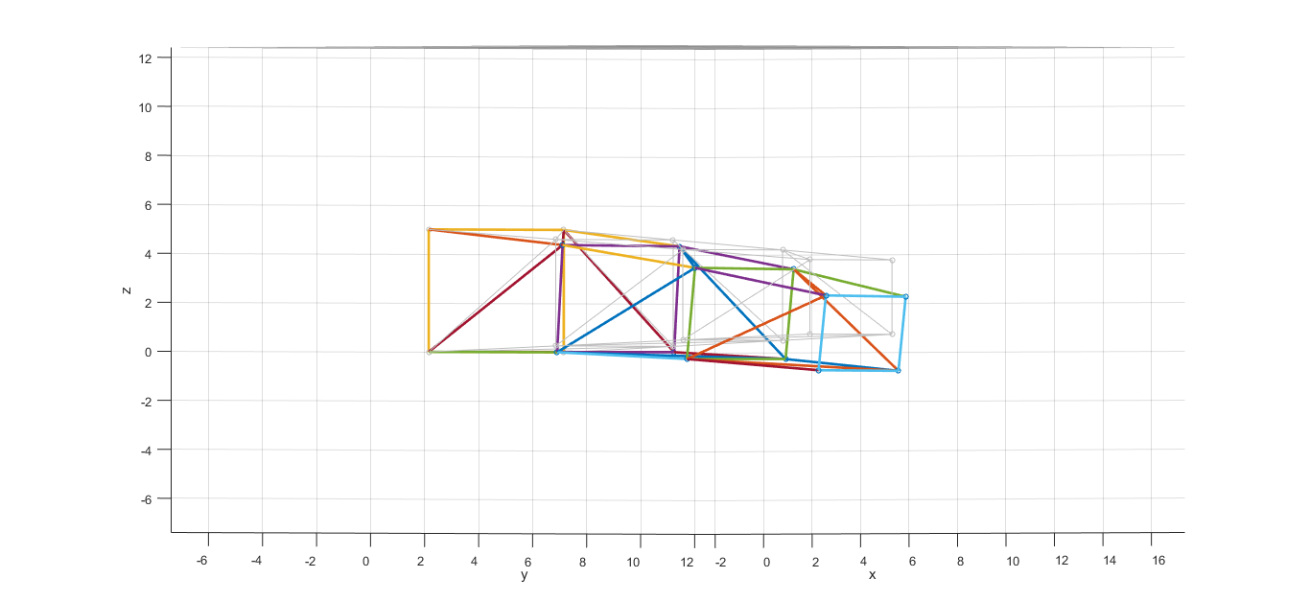**Figure 5: Deformed shape of complex crane structure in Matlab.**

## modal analysis for 5-element tapered beam

|  |  |  |
| --- | --- | --- |
| Comparison of Natural Frequency | | |
| ANSYS | Matlab | % error |
| 33.741 | 34.764 | 3.03% |
| 33.741 | 34.764 | 3.03% |
| 150.000 | 147.338 | -1.77% |
| 150.000 | 147.338 | -1.77% |
| 416.330 | 367.268 | -11.78% |
| 416.330 | 367.268 | -11.78% |
| 465.500 | 496.430 | 6.64% |
| 653.320 | 658.744 | 0.83% |
| 918.990 | 698.551 | -23.99% |
| 918.990 | 698.551 | -23.99% |
| 985.930 | 1054.913 | 7.00% |
| 1632.800 | 1165.836 | -28.60% |
| 1642.200 | 1165.836 | -29.01% |
| 1748.900 | 1647.567 | -5.79% |
| 1748.900 | 1758.783 | 0.57% |

## Mode shapes for 5-element tapered beam

Mode shape diagrams are included in the zip file. Using our 5-element beam, we found 30 total mode shapes. We are including the first 10 in the zip file.

## discussion

The results obtained using Matlab were much closer to closed form than those from ANSYS, as seen in the tables above. For the uniform beam, refining the mesh in Matlab is not necessary because a single element produces accurate results, with an error of ~ 0.001%. Conversely, ANSYS yields better results as the mesh is refined. For the tapered beam, refining the mesh yields more accurate results in both Matlab and ANSYS. The results of the complex shape were very close, as well. When comparing the first 15 natural frequencies obtained using Matlab and ANSYS, we observed greater differences because of the algorithms used in the calculations.

Looking at the rotated beam, we found that the results were identical. For example, when rotating the beam 450 in the X-Y plane, we found the deflections at the end of the beam to be (1.9291x10-4, -1.9291x10-4, 0). When taking the square root of the sum of the squares, the deflection equals -2.7282x10-4 m, which is the same as the un-rotated 1-element tapered beam. Similar results were found when rotating the beam in the X-Z and Y-Z planes. This verifies that the choice of coordinates does not affect the results. Hand calculation attached in the Appendix.

# Appendix

Code List

1. Main code file: beam2_project1.m
2. Shape function code: belshfuncs_Beam_2.m
3. Input files
   1. Uniform beam
      1. 1_element_1000N_uniform.txt
      2. 3_element_1000N_uniform.txt
      3. 5_element_1000N_uniform.txt
      4. 10_element_1000N_uniform.txt
   2. Tapered beam
      1. 1_element_1000N.txt
      2. 3_element_1000N.txt
      3. 5_element_1000N.txt
      4. 10_element_1000N.txt
      5. 20_element_1000N.txt
   3. Complex crane structure: project1_Complex.txt
   4. Rotation of tapered beam 450(for code validation)
      1. 1_element_Rotation_XYPLANE.txt
      2. 1_element_Rotation_YZPLANE.txt
      3. 1_element_Rotation_XZPLANE.txt
4. ANSYS files (in ANSYS_Files directory)
   1. Nodal Solution
      1. 1_element_1000N.txt
      2. 3_element_1000N.txt
      3. 5_element_1000N.txt
      4. 10_element_1000N.txt
      5. 20_element_1000N.txt
      6. UY_displacement_complex.txt
   2. Natural_frequencies.txt
   3. Tapered_beam_ANSYS.db
   4. Tapered_beam_Input_file.txt (to run ANSYS .db file)

